富氧燃烧提升燃煤火电灵活性技术
Oxygen-enriched Combustion Technology for Increasing Flexibility of Coal-fired Thermal Power Unit
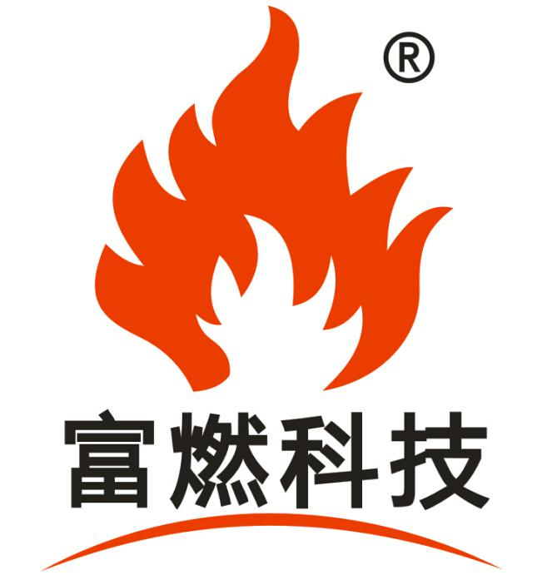

重庆富燃科技股份有限公司
Chongqing Furan Technology Co., Ltd.

富氧燃烧提升燃煤火电灵活性技术
Oxygen-enriched Combustion Technology for Increasing Flexibility of Coal-fired Thermal Power Unit
发展火电灵活性技术是低碳社会的国家要求，是大力发展可再生能源的技术要求，选择燃煤火力发电机组进行灵活性改造是国情的需要，是国情的必须选择。
Developing technologies of improving the flexibility of thermal power unit is not only the national requirement for building a low-carbon society, but also the technical requirement for vigorously developing renewable energy. Carrying out technology modification for coal-fired power units is a necessity and an inevitable choice according to China's actual conditions.
当然，选择燃煤火电实施灵活性改造必须要遵循火电灵活性的技术要求，
Certainly, technical requirements must be complied with during improving the flexibility of the thermal power unit by using coal-fired units.
即，（1）运行灵活性，包括：
Namely, (1) operational flexibility, including:
A） 20%~40%额定负荷深度调峰；
Capable of in-depth peak load regulation at 20% ~ 40% of the rated load;
B） 2~4h快速启停，
Quick start up and shut down in 2~ 4h;
C） 2%~5%MW/min爬坡能力（提升机组负荷升降速率）；
With a grade ability of 2% ~ 5% MW/min (lifting the power increasing rate of the unit under load)
（2） 燃料灵活性：煤种适应性强；
Fuel flexibility: The types of coal used shall have a strong flexibility;
（3） 低负荷时烟温满足脱硝要求；
The smoke temperature shall satisfy the requirements of denitration under low load;
（4） 在同比工况下不降低锅炉效率；
The boiler efficiency will not be reduced compared with that at the same working conditions;
（5） 热电机组实现热电解耦。
Thermoelectric decoupling can be achieved for the thermal power unit.
然而，国内燃煤火电机组灵活性不能满足要求，传统的火电机组在灵活性方面不是很理想：
However, the flexibility of domestic coal-fired thermal power units cannot meet the requirements as the traditional thermal power units are not flexible enough:
（1） 机组深度调峰能力差——纯凝机组调峰能力一般为额定容量的50%左右,典型的抽凝机组在供热期的调峰能力仅为额定容量的20%；
The unit has a poor in-depth peak load regulation capacity - the peak load regulation capacity of straight condensing unit is usually about 50% of the rated capacity, and that of the typical condensing unit is only 20% of the rated capacity during the heating period;
（2） 爬坡速度慢（机组负荷升降速率低）；
The unit has a low ramp rate (the power increasing rate of the unit under load is low);
（3） 锅炉启/停时间长；
The start-up & shutdown time of the boiler is long;
（4） 燃料适应性差；
The fuel used has a poor flexibility;
（5） 火力机组燃烧控制不够精细。
The combustion of the thermal power unit lacks a fine control system.
因此，我们需大力学习，引进国外先进的火电灵活性技术。
Therefore, we need to learn from others and introduce advanced technologies on improving the flexibility of thermal power units from abroad.
国外的灵活性技术先进性主要表现为：
The technical advancement on flexibility of abroad is mainly as follows:
A）. 20%额定负荷运行；
Capable of operating at 20% rated load;
B）. 快速启动（如：800MW超临界机组3h启动）；
Quick start (e.g.: a supercritical unit of 800MW can be started up in 3h);
C）. 3%MW/min爬坡能力（负荷升降速率）。
With a grade ability (the power increasing rate of the unit under load) of 3% MW/min
其主要技术措施有：
The main technical measures that have been taken include:
（1） 燃烧煤种的预处理
Pre-treat the fuel coal;
（2） 增加储热、再加热装置
Increase thermal storage and reheating devices;
（3） 采用新型材料，减薄壁厚
Use new materials and reduce the wall thickness;
（4） 优化制粉、供粉系统
Optimize the coal pulverizing system and pulverized coal supply system;
（5） 优化运行操作过程
Optimize the operation process.
但上述技术措施及技术的先进性很多是基于国外本土国情，如：电网小；热网小；煤种优质、稳定；易进行精细化管理；且多采用燃气机组进行灵活性调节，与我国的实际国情存在较大的差异，易产生衍生问题，出现“水土不服”的现象。
However, the above technical measures and advanced technologies are based on the national conditions of abroad. These countries may have a small power grid and a small heat supply network; the coal used is of a high quality and stability; in addition, gas-fired units are usually used for improving the flexibility. As a result, a fine management can easy to be carried out. These are different from the actual conditions of China so that derivative problems are easy to appear, such as an "acclimatized" phenomenon.
针对目前国内燃煤火电机组在灵活性调节方面存在的不足，重庆富燃科技股份有限公司经过多年实践应用，成功研发出了富氧燃烧提升燃煤火电灵活性技术，并在实际项目中得以成功实施。
As the domestic coal-fired thermal power units lack of flexibility in regulation at present, Chongqing Furan Technology Co., Ltd. has successfully developed the oxygen-enriched combustion technology for increasing flexibility of coal-fired thermal power unit after years of practical application and the technology has been successfully implemented in certain projects.
其技术机理如下：
Its technical mechanism is as follows:
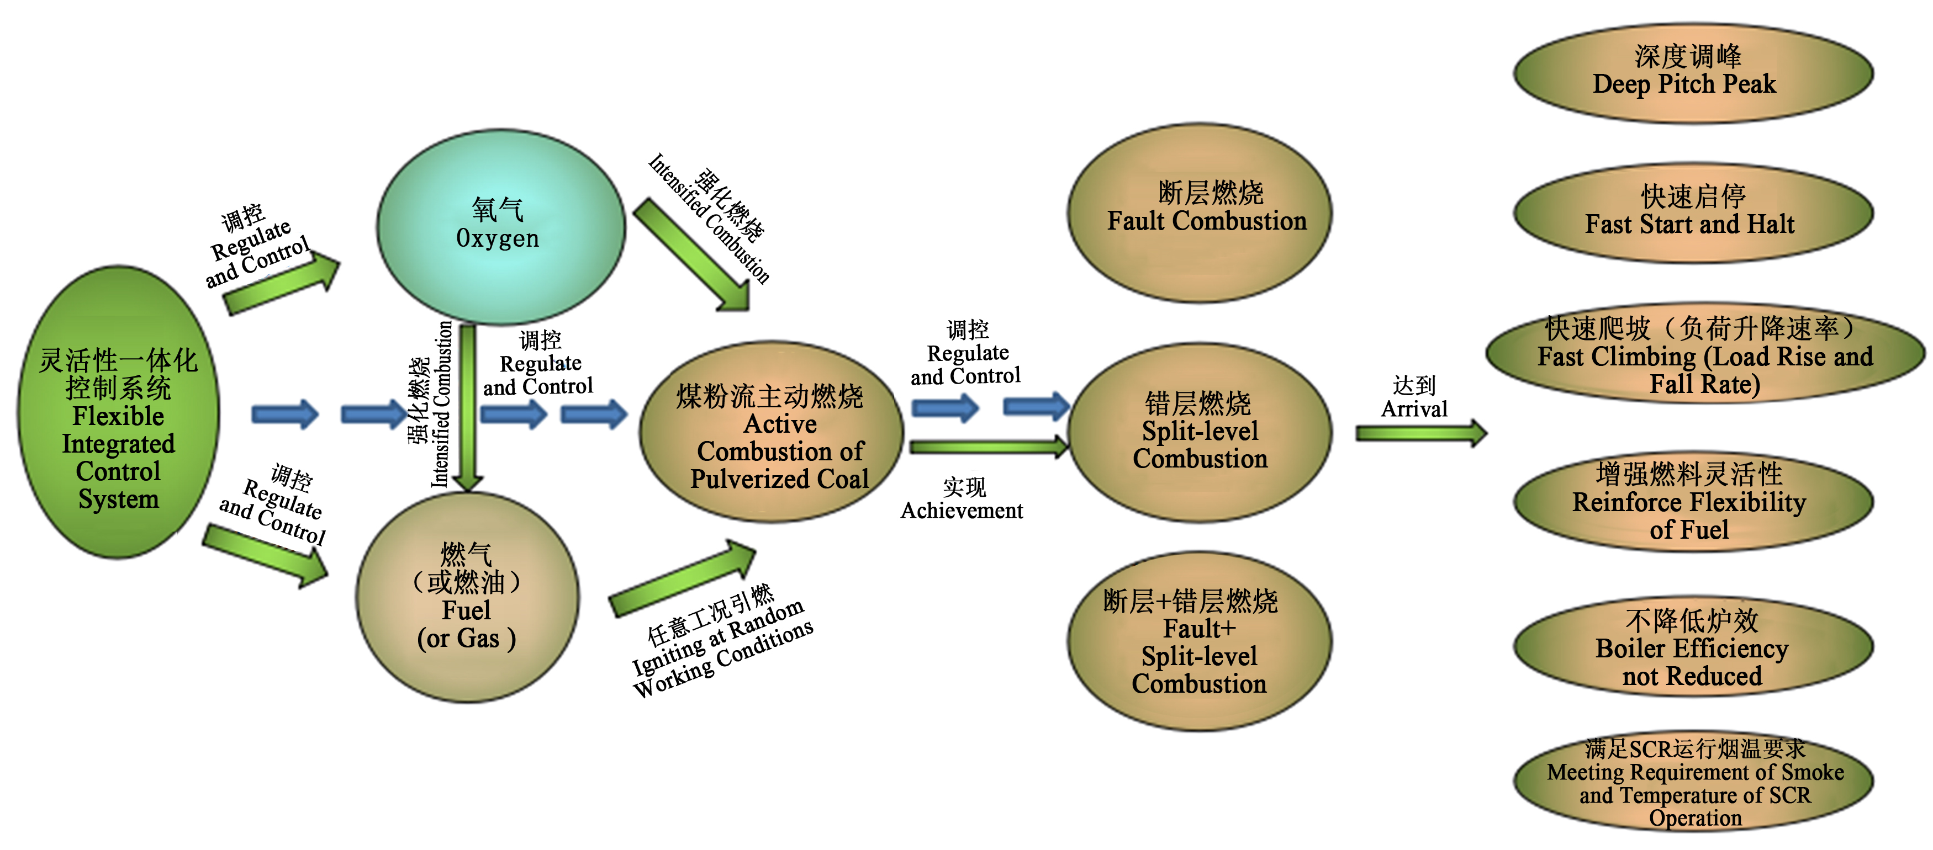 富氧燃烧提升燃煤火电灵活性技术采用了主动燃烧稳定结构设计与控制方法，利用小空间自稳燃烧方式，避免了原锅炉煤粉气流大空间燃烧的诸多限制条件，装置整体运行安全、稳定、连续，控制简单、易行，达到燃煤发电机组灵活性技术要求scheme
The oxygen-enriched combustion technology for increasing flexibility of coal-fired thermal power unit takes a design and a control method for achieving the active combustion stability. As a small space self-stabling burner is used, restrictions of the large space combustion of pulverized coal in the original boiler can be avoided. Thus, the unit can achieve an overall safe, stable and continuous operation and the control is easy and convenient, which can meet the technical requirements of coal-fired power generating units in flexibility.
富氧燃烧提升燃煤火电灵活性技术的关键：
The key of the oxygen-enriched combustion technology for increasing flexibility of coal-fired thermal power unit lies in:
1.装置与运行的安全性
Safety of Unit Operation
安全性包括以下三方面：
The safety lies in the following three aspects:
（1）炉内燃烧安全（利用富氧燃烧器，实现炉膛稳定燃烧，正负压波动小，安全可控）；
Safety of furnace combustion (The use of oxygen-enriched burner can achieve a stable combustion in furnace, generate small fluctuations of positive and negative pressure and ensure a safe and controllable operation);
（2）燃烧设备安全（利用智能燃烧系统，实现燃烧设备的监测、参数调控，确保装置无烧损、结渣风险）；
Safety of combustion equipment (The use of intelligent combustion system can achieve the monitoring of the combustion equipment and controlling of parameters to ensure that the unit is free of burning loss and slagging risk);
（3）供氧系统安全（利用氧气控制装置，实现氧气的智能、自动调控，确保供氧系统安全运行）。
Safety of oxygen system (The use of oxygen control device can achieve the intelligent and automatic control of oxygen to ensure the safe operation of the oxygen system.)
2. 装置与运行的稳定性
Stability of Unit Operation
稳定性主要包括以下三方面：
The stability lies in the following three aspects:
（1）燃油/燃气火焰燃烧稳定（采用复合型富氧微油/气枪，确保燃油/燃气燃烧稳定可控）；
Stability of oil/gas combustion (The complex oxygen-enriched oil/gas gun is used to ensure that the combustion of oil/gas is stable and controllable);
（2）煤火焰燃烧稳定（利用富氧燃烧器，实现燃烧器内提前着火燃烧，煤粉火焰稳定可控）；
Stability of coal combustion (The oxygen-enriched burner is used to achieve an early ignition of coal in the burner to ensure that the pulverized coal flame is stable and controllable);
（3）供氧系统稳定运行（利用超低温真空智能储罐及氧气控制装置，实现供氧的稳定可控）。
Stable operation of oxygen system (The intelligent cryogenic vacuum tank and oxygen control device are used to achieve a stable and controllable oxygen supply.)
3、 装置与运行的连续性
Continuity of Unit Operation
连续性主要包括以下三方面：
The continuity mainly lies in the following three aspects:
（1）供油/供气系统连续性（利用燃油/气预处理装置，确保供油的连续性）；
Continuity of oil/gas supply system (The oil/air pretreatment device is used to ensure the continuity of oil supply);
（2）煤粉燃烧连续性（利用富氧燃烧器与智能燃烧系统，调控燃烧参数，确保煤粉火焰延展性、连续性好）；
Continuity of pulverized coal combustion (The oxygen-enriched burner and intelligent combustion system are used to regulate the combustion parameters so as to ensure that the pulverized coal flame has a good ductility and continuity);
（3）供氧系统连续性（利用超低温真空智能储罐、氧气控制装置，调控供氧系统参数，实现供氧系统24小时备用，确保供氧的及时性、大量性、连续性）。
Continuity of oxygen system (The intelligent cryogenic vacuum tank and oxygen control device are used to regulate the parameters of oxygen system, so as to achieve a 24-hour standby oxygen system and ensure that the supply of oxygen is timely, enough and continuous.)

4. 煤种的适应性
Coal Flexibility
煤种适应性主要体现在：可大幅提升机组煤种应用范围，实现燃用煤矸石、无烟煤、贫煤、烟煤、褐煤等煤种。
The coal flexibility mainly lies in that the application of coal is greatly expanded for the unit that burning of coal gangue, anthracite, lean coal, bituminous coal, lignite and other types of coal is applicable.
富氧燃烧提升燃煤火电灵活性技术的主要性能：
The functions of the oxygen-enriched combustion technology scheme for increasing flexibility of coal-fired thermal power unit mainly lie in:
增强深度调峰能力——煤粉以提前主动燃烧状态进入炉膛，提高炉膛温度，保证整个锅炉煤粉不会因为炉膛热负荷过低燃烧不稳而熄火，实现锅炉不停炉超低负荷（最低20%额定负荷）调峰，增强火电机组深度调峰能力。
Enhance the in-depth peak load regulation capacity - In order to improve the furnace box temperature, pulverized coal is supplied into the furnace in an active advanced ignition state to ensure that the pulverized coal in the boiler would not flame out due to an unstable combustion as the thermal load in the furnace is too low. Therefore, the peak load regulation of the boiler at an ultra-low load (20% of the rated load at minimum) can be carried out without shutdown and the enhancement of in-depth peak load regulation capability of the thermal power unit is achieved.
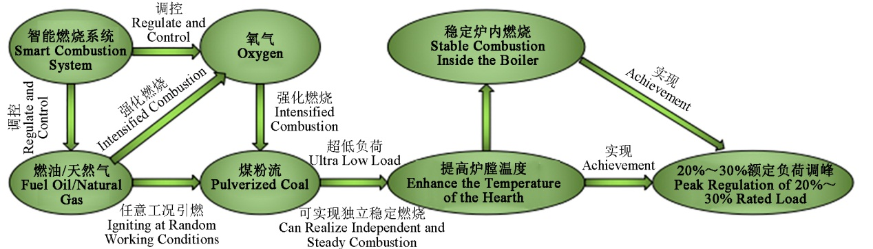 提升机组爬坡速度（负荷升降速率）——一次风煤粉流以多层（点）投运，避免传统逐层投运导致的升负荷慢、主蒸汽温度及压力不能同步增长或增长较慢等问题，在保证炉内燃烧安全的前提下，可实现增加单位时间内的入炉煤量，确保机组快速提升负荷，大幅提升燃煤火电机组爬坡速率（负荷升降速率）。
Improve the climbing speed of power generator set (lifting rate of the load) ----primary-air pulverized coal flow will be put into operation by multilayer (multi-point), avoiding problems such as slow upgrade of load, the main steam temperature and the pressure fail to rise simultaneously or rise slowly and other problems caused by traditional layer-by-layer operation. Under the precondition that the combustion inside the boiler is safe, you can increase the quantity of coal entered into the boiler by unit time, ensuring that the power generator set improves the load rapidly, so as to substantially upgrade the climbing speed (lifting rate of the load) of the coal-fired thermal power generator set.
降低锅炉启/停时间——一次风煤粉流多层（点）投运，根据工况需求灵活调整入炉煤量，实现快速增/减投煤量，从而达到降低锅炉启/停时间的目的。
Reduce start/halt time of boiler----primary air pulverized coal flow will be put into operation in multilayer (multi-point), flexibly adjust the quantity of coal entering the boiler in accordance with the need of working conditions, achieving fast increase/decrease of coal feeding quantity, thus reaching the objective of reducing start/halt time of boiler.
增强燃料灵活性——利用氧气强化煤粉中固碳的燃烧，实现对煤粉挥发份含量不做要求，有效提高锅炉煤种适应性；实现能够燃烧烟煤、贫煤、无烟煤以及掺烧生物质能源（秸秆、木屑等）的目的，达到提高机组燃料灵活性的目的。
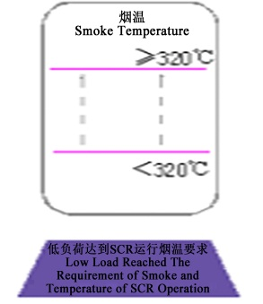 Reinforce the flexibility of fuel----intensify the combustion of solid carbon in the pulverized coal, no requirement on the content of the volatile matter of the pulverized coal, effectively improve the adaptability of the coal type of the boiler; realize the target of burning the bituminous coal, meagre coal and anthracite as well as admix-burning of biomass energy (straw, wood flour and so on) and achieve the target of improving flexibility of the fuel of power generator set.
确保SCR装置高效投运——利用多层（点）的燃烧，抬高火焰中心，缩短火焰中心到炉膛出口的距离，使烟气温度满足SCR投运要求（≥320℃），全程安全、高效地投运。
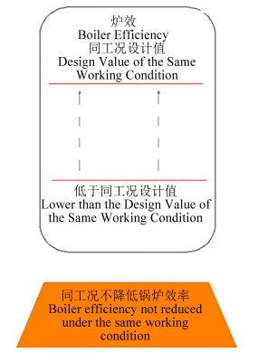Guaranteehigh-efficient operation ofSCR equipment------apply multilayer (multi-point) combustion, elevate the center of the flame, shorten the distance between the flame center and the exit of the boiler, enable the temperature of the smoke meeting the SCR operation requirement(≥320℃), ensure safe and effective operation in whole process.
确保同比工况炉效不降低——采用提前着火、主动燃烧的方式，相对延长了煤粉在炉内的燃烧时间，降低锅炉飞灰及大渣含碳量；同时抬高火焰中心，缩短火焰中心到炉膛出口的距离，避免为提高烟气温度而开启（或安装）省煤器旁路等措施，确保同比工况炉效不降低。
Guarantee the efficiency of boiler not to be reduced under the working condition on year-on-year basis----adopt preignition and active combustion, relatively prolong the combustion time of pulverized coal in the boiler, reduce the fly ash of the boiler and the carbon content of big slag; meanwhile, elevate the flame center, shorten the distance between the flame center and the exit of the boiler, avoid opening (or installing) the measures such as bypass of economizer with the purpose to enhance the smoke temperature, and ensure that the efficiency of boiler not to be reduced on year-on-year basis.
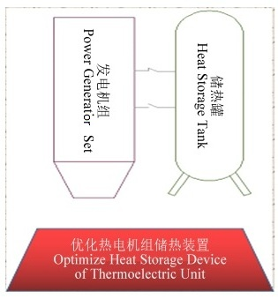 优化热电机组储热装置——利用富氧燃烧增强机组深度调峰能力，保证火电灵活性调节的连续性，从而优化热电机组储热装置，缩减其建设规模，降低基建及运行维护成本。
Optimize the heat storage device of thermoelectric unit-----use oxygen-enriched combustion to strengthen the deep pitch peak capacity of the power generator set, ensure the continuity of adjustment of thermal power flexibility, so as to optimize the heat storage device of thermoelectric unit, reduce its construction scale and reduce the cost of capital construction and operation maintenance.
本技术技改方案为：
Technical improvement schemes of this technology are as follows:
- 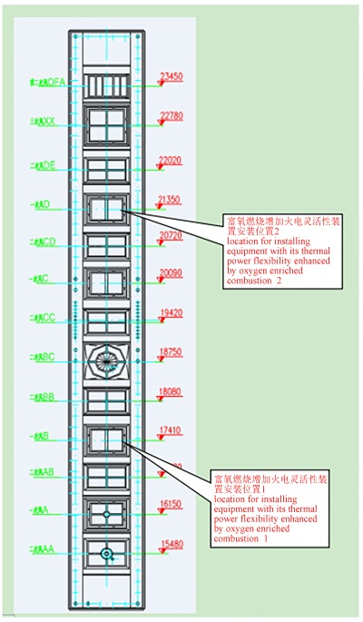切圆燃烧锅炉技改方案的实施
Implementation of Technical Innovation Scheme of Tangential Firing Boiler
采用断层富氧燃烧方式，对图所示1、2点所对应的燃烧器进行技术改造。
Adopt fault oxygen-enriched combustion method to implement technical improvement for the combustor corresponding to point 1 and point 2 in the figure.
技改后，在锅炉启停阶段改造点1作为主点火层使用，改造点2可作为辅助点火层使用；在机组深调阶段，改造点1、2同时投运可实现断层燃烧，以适应富氧燃烧提升燃煤火电灵活性技术需要。
After the technical improvement, at the start/halt stage of the boiler, the improvement point 1 will be used as the main igniting layer while the improvement point 2 will be used as auxiliary igniting layer; in the deep adjustment stage of the power generator set, the simultaneous putting into use of the improvement point 1 and point 2 can achieve fault combustion, so as to adapt to the technical needs of coal-fired thermal power flexibility .
（2）对冲燃烧锅炉技改方案的实施
Implementation of Technical Scheme of Hedging Combustion Boiler
采用断层+错层富氧燃烧方式，对图所示1、2、3点进行技术改造。
Adopt fault+ split- level oxygen enriched combustion method to implement technical improvement on point 1, point 2 and point 3 in the figure.
技改后，在锅炉启停阶段改造点1作为主点火层使用，改造点2、3可作为辅助点火层使用；在机组深调阶段，改造点1、2、3可实现断层+错层燃烧，以适应富氧燃烧提升燃煤火电灵活性技术需要。
After the technical improvement, in the boiler start/halt stage, improvement point 1 will be used as main igniting layer while point 2 and point 3 can be used as auxiliary igniting layers; in the deep adjustment stage of the power generator set, improvement point 1, point 2 and point 3 can realize fault +split level combustion, so as to adapt to the technical needs of improving coal-fired thermal power flexibility by oxygen enriched combustion.
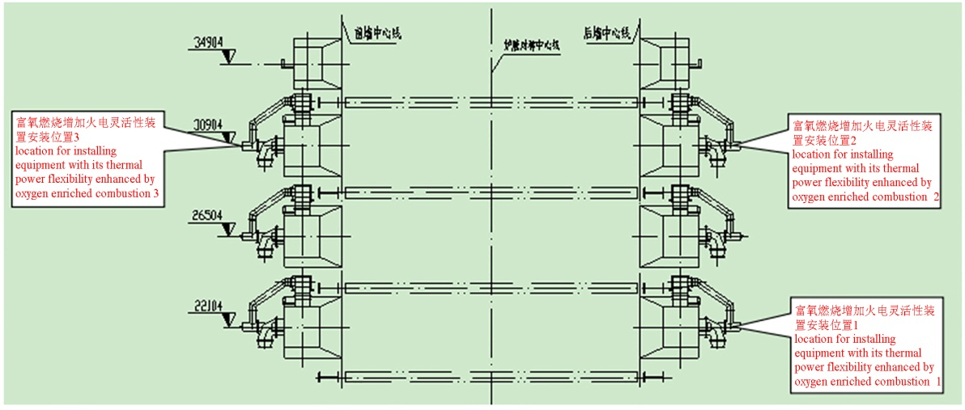
（3）W型火焰燃烧锅炉技改方案的实施
Implementation of Technical Scheme of Boiler of W-Shape Flame Combustion
采用错位富氧燃烧方式，对图所示燃烧器进行技术改造。
Adopt dislocation oxygen enriched combustion method to conduct technical improvement for the combustor in the figure.
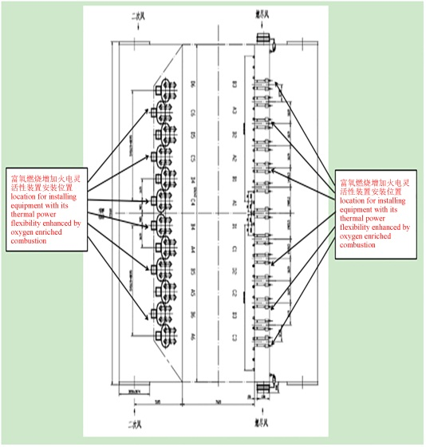 技改后，通过错位稳定燃烧，确保炉内受热更为均匀，通过调节下部二次风，抬高“W”火焰，以适应富氧燃烧提升燃煤火电灵活性技术需要。
After technical improvement, ensure more average heating in the boiler through dislocation stable combustion, and elevate “W” flame through adjusting the secondary air at the lower part, so as to adapt to the technical needs of improving coal-fired thermal power by oxygen-enriched combustion.
本技术应用业绩：(TFQ)
The Achievement of this Technology Application:
在国电投重庆九龙电厂的实际应用
Actual Application in Chongqing Jiulong Power Station of State Power Investment Corporation
国电投重庆九龙电厂为200MW机组四角切圆燃烧锅炉。
Chongqing Jiulong Power Station of State Power Investment Corporation is corner tangential firing boiler of 200 MW power generator set.
下面是实际调峰曲线及相关数据统计表
The actual pitch peak curve and relevant data statistical table is as follows:
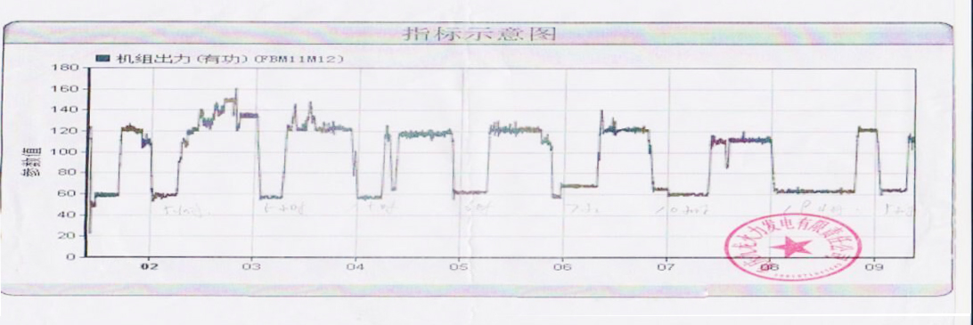
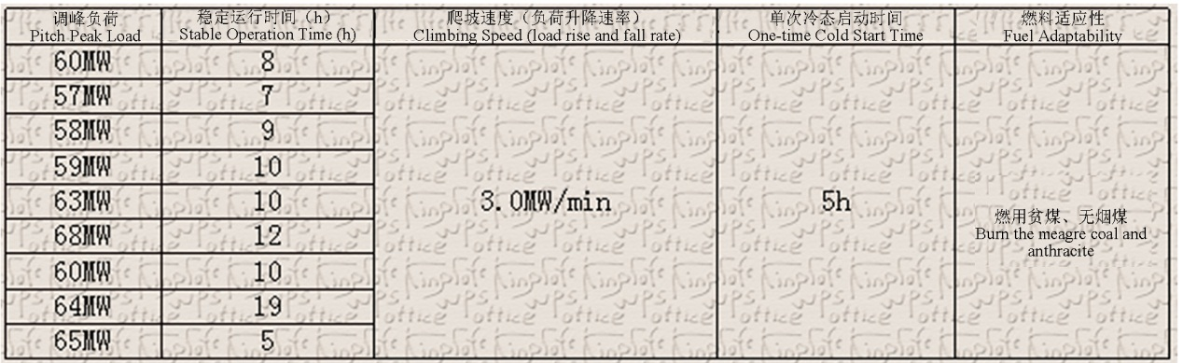
根据调峰曲线及数据表明：
The pitch peak curve and the date demonstrate that:
（1）实际应用中机组达到30%额定负荷（60MW）调峰，大幅提高了锅炉深度调峰能力；
In the actual application, the power generator set reached 30% rated load (60MW) pitch peak, which substantially improved the deep pitch peak ability of the boiler;
（2）在仅改造锅炉底层4台燃烧器的情况下，实现锅炉爬坡能力达到1.5%额定负荷/min，在实行多层（点）投运后，预期爬坡能力实现＞2.5%额定负荷/min；
Under the condition that only 4 sets of combustor at the bottom layer of the boiler are improved, the climbing ability of the boiler reached 1.5% rated load /min, after implementing multilayer (multipoint) operation, the expected climbing ability reaching ＞2.5% rated load /min;
（3）在仅改造锅炉底层4台燃烧器的情况下，实现锅炉启动时间≤5h，在实行多层（点）投运后，可大幅提升机组爬坡速率（负荷升降速率），实现快速带上满负荷，预期启动时间≤4h。
Under the condition that only 4 sets of combustors at the bottom layer of the boiler are improved, the start time of the boiler reached ≤5h, after implementing multilayer (multi-point) operation, substantially enhance climbing speed (lifting rate of the load) of the power generator set, realizing quick belt feeding full load, the expected start time is ≤4h.
（4）同时实现燃用贫煤、无烟煤。
Meanwhile, realize the combustion of meagre coal and anthracite.

在国电重庆恒泰电厂的应用

Application in Chongqing Hengtai Power Station of State Power Investment Corporation
国电重庆恒泰电厂为300MW机组四角切圆燃烧锅炉。
Chongqing Hengtai Power Station of State Power Investment Corporation is corner tangential firing boiler of 300 MW power generator set.
下面是实际调峰曲线及相关数据统计表
Actual pitch peak curve and relevant data statistic table is as follows:
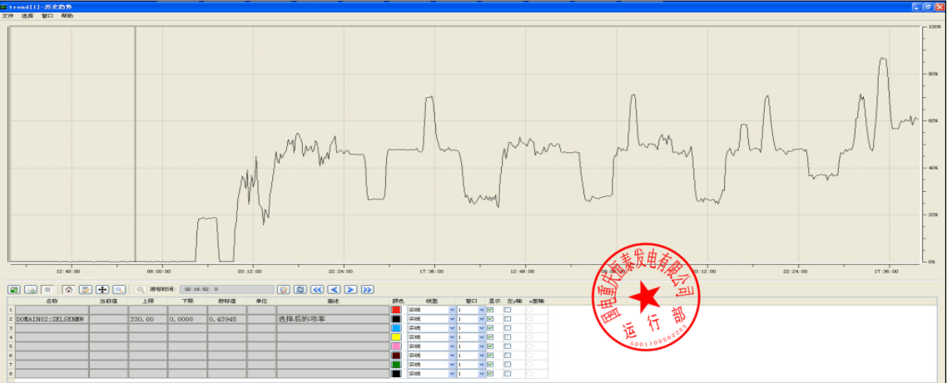
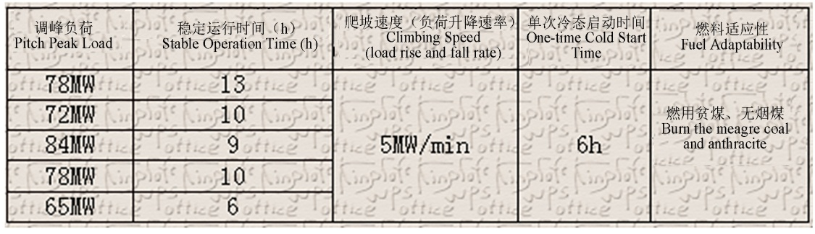
根据调峰曲线及数据表明：
The pitch peak curve and data demonstrate that:
（1）实际应用中机组达到21%额定负荷（65MW）调峰，大幅提高了锅炉深度调峰能力；
In the actual application, the power generator set reached 21% rated load (65 MW) pitch peak, substantially enhanced deep pitch peak ability of the boiler;
（2）在仅改造锅炉底层4台燃烧器的情况下，实现锅炉爬坡能力达到1.7%额定负荷/min，在实行多层（点）投运后，预期爬坡能力实现＞2.5%额定负荷/min；
Under the condition that only 4 sets of the combustors at the bottom layer of the boiler are improved, the climbing ability of the boiler reached 1.7% rated load /min, after implementing multilayer (multipoint) operation, the expected climbing ability reached ＞2.5% rated load /min;
（3）在仅改造锅炉底层4台燃烧器的情况下，实现锅炉启动时间≤6h，在实行多层（点）投运后，可大幅提升机组爬坡速率（负荷升降速率），实现快速带上满负荷，预期启动时间≤4h。
Under the condition that only 4 sets of combustors at the bottom of the boiler are improved, the start time of the boiler reached ≤6h, after implementing multilayer (multi-point) operation, the climbing speed (lifting rate of the load) of the power generator set is substantially enhanced, realizing quick belt feeding full load, the expected start time ≤4h.
（4）同时实现燃用贫煤、无烟煤。
Meanwhile, achieve the combustion of meagre coal and anthracite.
我司技术与国外先进技术的对比
Comparison of technology between our Company and overseas advanced technology
技术优势主要体现在以下几点：
Technical advantages mainly manifest as follows:
第一、富氧燃烧增强火电灵活性技术实现了对燃料挥发份含量不做要求，有效提高锅炉煤种适应性。
First, the enhancement of technology of thermal power flexibility by oxygen enriched combustion realized no requirement on content of volatile matter of the fuel, which effectively improved the adaptability of coal type of the boiler.
第二、富氧燃烧增强火电灵活性技术多层（点）投运，有效地增加了锅炉吸热效率。
Second, multilayer (multi-point) operation of enhancing technology of thermal power flexibility by oxygen enriched combustion effectively increased the heat absorption efficiency of the boiler.
第三 、富氧燃烧增强火电灵活性技术可适应0.16~0.8kg/kg风粉比浓度，满足工况的热量需求。
Third, enhancing the technology of thermal power flexibility by oxygen enriched combustion can adapt to 0.16~0.8kg/kg concentration of air to pulverized coal ratio, satisfying the heat demand of the work condition.
第四、实现增加单位时间内的入炉煤量，确保机组快速提升负荷，大幅提升火电机组爬坡速率。
Fourth, realize the increase of quantity of coal entering the boiler by unit time, ensuring the power generator set to upgrade the load, and substantially enhance the climbing rate of the thermal power generator set.
第五、灵活性一体化控制操作安全、简单、及时、稳定。
Fifth, flexible integrated control and operation is safe, simple, timely and steady.
第六、优化热电机组储热装置。
Sixth, optimize the heat storage devices of thermoelectric unit.
第七、提高低负荷下锅炉烟气温度，满足SCR运行烟温要求；
Seventh, enhance the boiler smoke temperature under low load, meet requirement of smoke and temperature for SCR operation;
第八、同比工况下不降低锅炉炉效；
Eighth, the efficiency of the boiler not reduced under the work condition on year-on-year basis;
成本优势主要体现在以下几点：
Cost advantages are mainly as follows:
第一、不需要对燃烧煤种进行预处理
First, no need to conduct preprocessing of coal type of the combustion.
第二、不需要增加再加热装置
Second, no need to increase reheating devices.
第三、减少新型材料的利用，降低机组改造成本
Third, reduce the use of new type of materials, and lower the cost of improvement of the power generator set.
第四、不需要改造制粉、供粉系统
Fourth, no need to improve the powder process and power supply system.
第五、灵活性一体化控制系统对机组原控制操作系统改动量小
Fifth, the flexible integrated control system make small change of the original control and operation system.
第六、降低热电机组储热装置基建及运行成本
Sixth, reduce the cost of capital construction and operation of heat storage device of the thermoelectric unit.

